# SOCIAL MEDIA DASHBOARD

### A MINI PROJECT REPORT

#### Submitted by

#### Group/Team No: G5/T14

*1.Arshvir Singh Deol (2310990385)*

*2.Arpit Goel (2310990382)*

*3.Arvin (2310990386)*

*4.Arsh Beri (2310990383)*

#### in partial fulfillment for the award of the degree of

## BACHELEOR OF ENGINEERING

***in***

COMPUTER SCIENCE & ENGINEERING



**CHITKARA UNIVERSITY**

**CHANDIGARH-PATIALA NATIONAL HIGHWAY**

**RAJPURA (PATIALA) PUNJAB-140401 (INDIA)**

##### Decemberr 2023

Page | 1

###### TABLE OF CONTENTS

|  |  |  |
| --- | --- | --- |
| **Sr.no** | **Section** | **Page No.** |
| 1. | Introduction | 3 |
| 2. | Problem Statement | 4 |
| 3. | Technical Details | 5 |
| 4. | Key Features | 6 |
| 5. | Project Advantages | 7 |
| 6. | Results | 8-21 |
| 7. | Conclusion | 22 |
| 8. | References | 23 |

Page | 2

**Introduction**

**1.Project introduction**

Welcome to **SOCIAL MEDIA DASHBOARD** - a cutting-edge solution for social media management. In a world dominated by digital interactions, our project is designed to simplify the complexities of social media analytics, offering users a unified and intuitive dashboard for informed decision-making.

**Key Points:**

**Objective:** Streamlining social media data management.

**Purpose:** Empowering users with actionable insights.

**Focus:** Enhancing user experience through a user-friendly interface.

*In a digital age where data overload is a challenge, Social Media Dashboard emerges as a timely and essential tool. Join us as we redefine how users navigate and succeed in the dynamic landscape of social media.*

**2. Team Introduction**

This Project is allocated to Team no. 14 of Group 5. The team comprises of 4 members-

* Arshvir Singh Deol (2310990385)
* Arpit Goel (2310990382)
* Arvin (2310990386)
* Arsh Beri (2310990383)

The team is led by Arpit Goel (2310990382).

Page | 3

**Problem Statement**

**Social Media Dashboard.**

Imagine you're trying to make sense of the massive amount of information flooding your social media feeds every day. It's like trying to find a needle in a haystack - overwhelming and time-consuming. Right now, there's no easy way to bring together all the important data from different platforms and make sense of it quickly.

**Problems We're Solving:**

1. **Too Much Information:** It's like having too many tabs open, making it hard to focus on what really matters.
2. **No Central Hub:** There's no one-stop-shop for all your social media data, making it a hassle to check everything.
3. **Analysis Headaches:** Figuring out what's working and what's not takes way too much time and effort.

**Why it Matters:**

* Decision-making is slow because we're drowning in data.
* We miss out on opportunities to connect with our audience effectively.
* It's tough to know if our social media efforts are actually paying off.

**Our social media dashboard is here to simplify all of this. It's like having a personal assistant for your social media, bringing everything together in one place, so you can make smarter decisions without the headache.**

Top of Form

Page | 4 **TECHNICAL DETAILS**

***Our approach to developing the social media dashboard involved a strategic and user-focused methodology***:

1. **Understanding the Landscape:**
   * Conducted in-depth research to comprehend the evolving challenges users face in managing social media data.
   * Analyzed existing solutions to identify shortcomings and opportunities for improvement.
2. **Defining Scope and Requirements:**
   * Clearly outlined the scope of our dashboard, detailing what functionalities it would encompass and what it wouldn't.
   * Gathered user requirements through surveys, interviews, and continuous feedback loops to ensure alignment with user expectations.
3. **Selecting the Right Tools:**
   * Carefully chose technologies and frameworks based on criteria such as scalability, user-friendliness, and compatibility with diverse data sources.
4. **User-Centric Design:**
   * Prioritized user experience by implementing an intuitive design and easy navigation.
   * Incorporated user feedback at each stage of development to refine and enhance features, ensuring the final product resonates with user preferences.

Top of Form

*By following this methodology, we aimed to deliver a social media dashboard that not only addresses the identified challenges but also aligns closely with user expectations, providing a seamless and valuable experience for our users.*

Page | 5

**Key Features**

***Our social media dashboard is designed to empower users with a range of essential features, ensuring a comprehensive and user-friendly experience:***

1. ***Unified Dashboard:***
   * *Centralized view of all social media metrics in one place for a holistic understanding of performance.*
2. ***Real-time Analytics:***
   * *Instant access to up-to-the-minute data, allowing users to respond promptly to trends and engagements.*
3. ***Customizable Reports:***
   * *Tailor reports based on individual preferences, enabling personalized insights for different stakeholders.*
4. ***Sentiment Analysis:***
   * *Understand audience sentiment through advanced analytics, helping in crafting targeted and resonant content.*
5. ***Engagement Tracking:***
   * *Monitor likes, comments, and shares to gauge the effectiveness of social media campaigns and content.*
6. ***Content Performance Metrics:***
   * *Detailed analysis of post reach, engagement, and conversions to optimize content strategy.*
7. ***User-Friendly Interface:***
   * *Intuitive design for easy navigation, ensuring that users can efficiently access and interpret data.*

*These features collectively ensure that our social media dashboard is a powerful tool, providing users with the insights and capabilities needed to enhance their social media presence and impact.*

Page | 6

**Project Advantages**

**Our social media dashboard offers a myriad of advantages, revolutionizing the way users interact with and leverage social media data*:***

1. **Time Efficiency:**
   * Streamlines data analysis, saving valuable time in interpreting complex metrics and trends.
2. **Comprehensive Insights:**
   * Provides a holistic view of social media performance, consolidating data from various platforms for a comprehensive analysis.
3. **Strategic Decision-Making:**
   * Empowers users with actionable insights, enabling informed and strategic decision-making for effective social media campaigns.
4. **User-Friendly Interface:**
   * Boasts an intuitive design, making it accessible to users of all levels of technical expertise.
5. **Real-Time Monitoring:**
   * Facilitates instant tracking of real-time data, ensuring users stay ahead of trends and capitalize on timely opportunities.
6. **Enhanced Engagement:**
   * Facilitates the creation of targeted and impactful content by providing sentiment analysis and engagement tracking.
7. **Cross-Platform Integration:**
   * Seamlessly integrates with major social media platforms, providing a unified experience across channels.
8. **Automated Alerts:**
   * Keeps users informed with automated alerts for significant changes in key metrics, ensuring timely response to critical developments.
9. **Historical Data Analysis:**
   * Enables a deeper understanding of long-term trends through historical data analysis, supporting strategic planning.

Top of Form

Page | 7

**Results**

Login Page

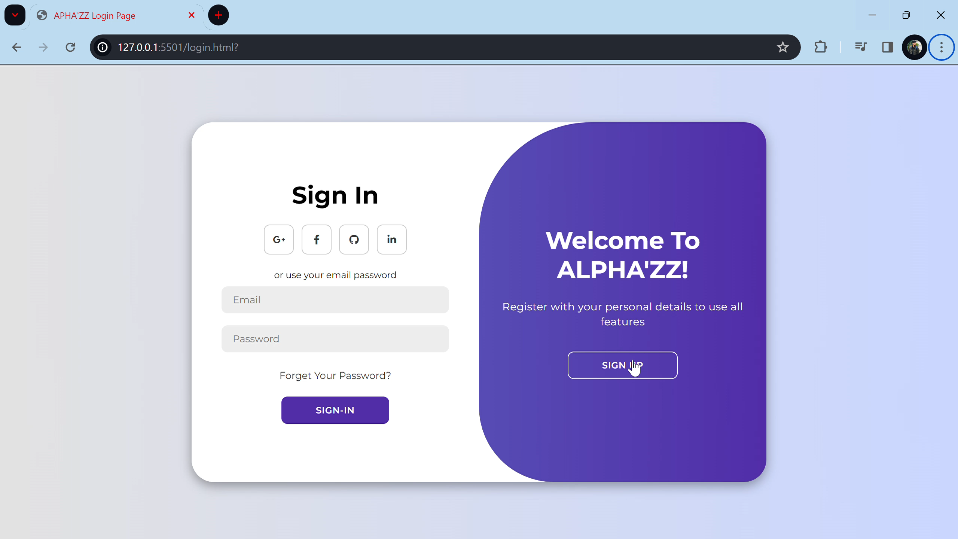

**Main Web Page**

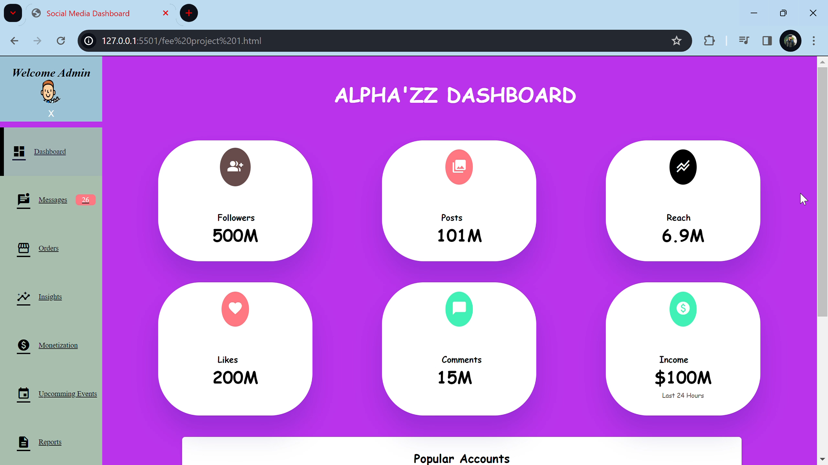

Page | 8

**Login page Source code (HTML)**

***Tags used in the above code:***

1. **Div Tag (<div>):** Acts as a container to group and structure HTML elements for styling and layout purposes.
2. **Input Tag (<input>):** Creates form controls for user input, such as text fields, checkboxes, or radio buttons.
3. **H1 Tag (<h1>):** Defines the main heading of a page, representing the highest level of importance.
4. **Form Tag (<form>):** Creates an HTML form for user input, containing various form elements like text fields and buttons.

Page | 9

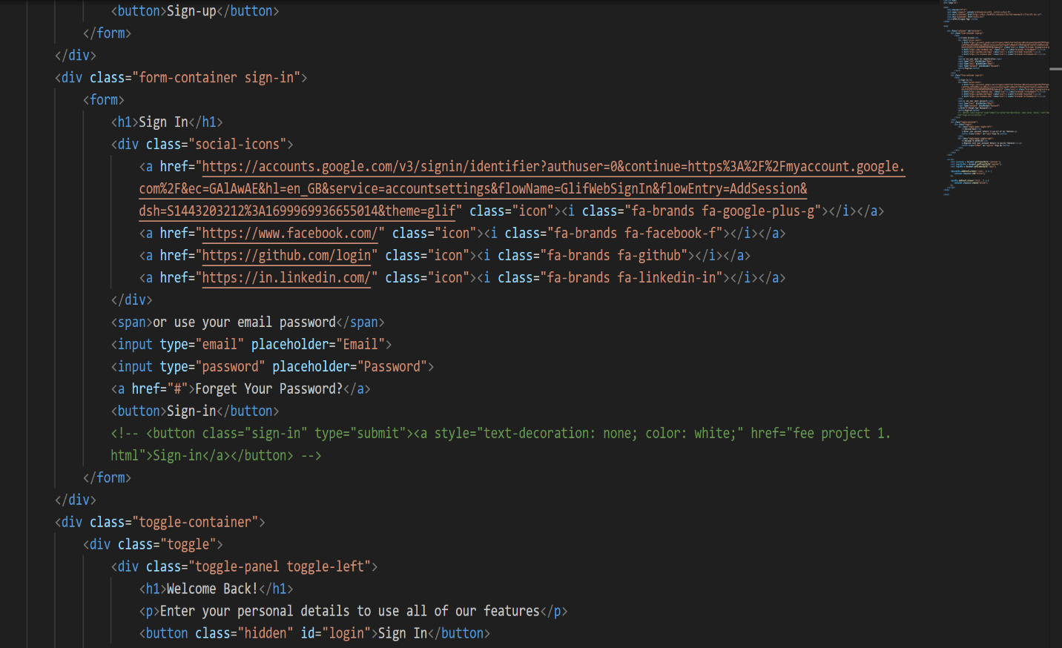

***Tags used in the above code:***

1. **Button Tag (<button>):** Creates clickable buttons for user interactions, often used within forms or standalone.
2. **Span Tag (<span>):** Inline container for applying styles or scripting to specific text or elements within a larger content block.
3. **Anchor Tag (<a>):** Used to create hyperlinks between web pages or within the same page.

Page | 10

**Login page Source code (CSS)**

***Styles used:***

1. **Display Flex:** Establishes a flex container for flexible layout, allowing items to align and distribute within a container.
2. **Box Shadow:** Adds a shadow effect to an element, providing depth and dimensionality in the form of horizontal and vertical shadows.
3. **Position:** Determines the positioning method of an element, specifying its placement in the document relative to its containing element.
4. **Border:** Defines the border properties of an element, including width, style, and color, to create visual boundaries.

Page | 11

***Styles used:***

1. **Transform:** Applies various transformations to an element, such as scaling, rotating, skewing, or translating, to alter its appearance.
2. **Transition:** Manages the smooth transition of CSS property changes over a specified duration, enhancing user interface interactions.
3. **Height:** Sets the vertical dimension of an element, defining its extent along the y-axis.
4. **Width:** Sets the horizontal dimension of an element, determining its extent along the x-axis.

Page | 12

***Styles used:***

1. **Font Size:** Specifies the size of text within an element, determining its visual appearance.
2. **Color:** Defines the text or foreground color of an element, enhancing its visual presentation.
3. **Margin:** Sets the space outside an element, creating separation from adjacent elements.
4. **Padding:** Determines the space between the content and the border of an element, influencing its internal layout and appearance.

Page | 13

**Login page Source code (JavaScript)**

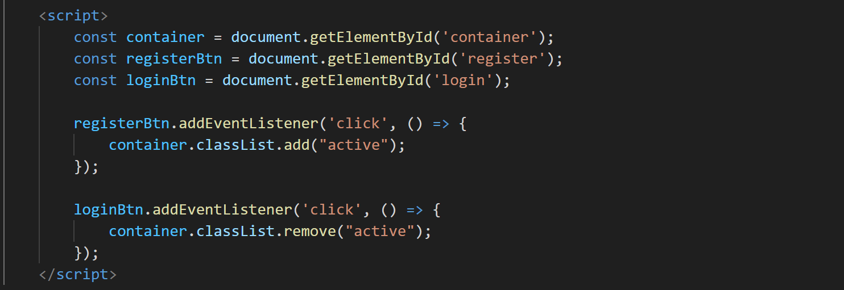

***Javascript tags used :***

1. **AddEventListener:** Method used to attach an event listener to an HTML element, enabling the execution of a function in response to a specified event.
2. **GetElementById:** Retrieves an HTML element from the document using its unique identifier (ID).
3. **Const:** A keyword in JavaScript used to declare a constant variable, whose value cannot be reassigned after initialization.
4. **Click Event:** A type of user interface event triggered when a mouse click occurs on an HTML element, commonly used with event listeners to execute associated functions.

Page | 14

**Main page source code (HTML)**

***Tags and attributes used:***

1. **Classes:** HTML attribute for grouping and styling multiple elements.
2. **IDs:** HTML attribute providing a unique identifier for a specific element.
3. **Image Tag (<img>):** Embeds images in a webpage with specified source and optional attributes.
4. **Anchor Tag (<a>):** Creates hyperlinks, linking to other web pages or resources.

Page | 15

Page | 16

Page | 17

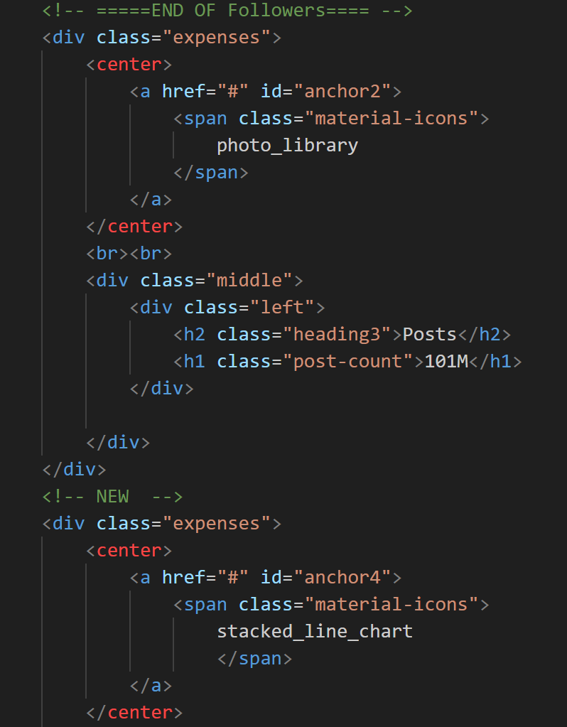

Page | 18

**Main page source code (CSS)**

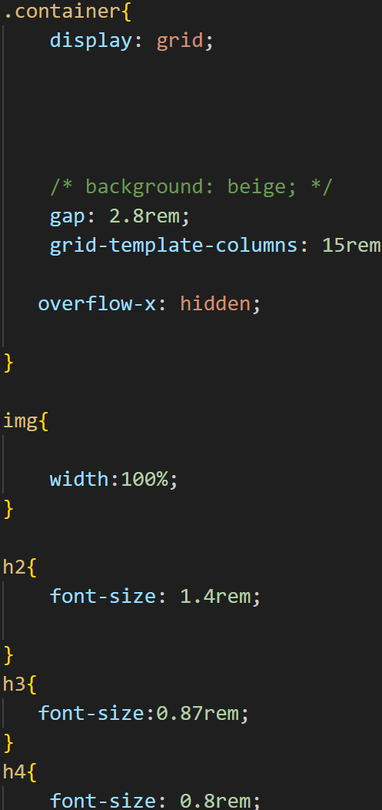

Page | 19

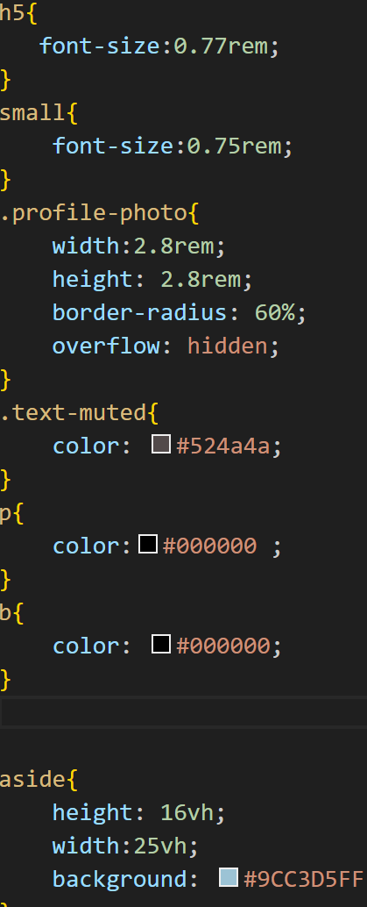

Page | 20

**Main page source code (JavaScript)**

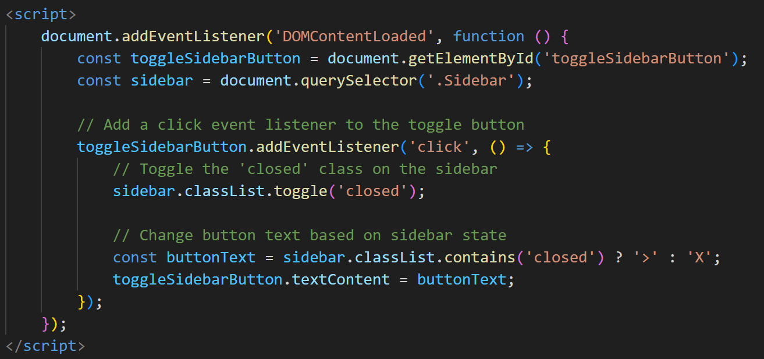

***Javascript tags used:***

**1.Toggl**e: A method to switch between the visible and hidden states of an element; **2.QuerySelector:** A DOM method to select the first element that matches a specified CSS selector.

**3.AddEventListener**: A method to bind an event listener to an HTML element, enabling the handling of specific events.

Page | 21

**Conclusion**

As we reflect on the journey of developing **SOCIAL MEDIA DASHBOARD**, our team has gained invaluable insights and experiences:

**Collaboration and Synergy:**

The project emphasized the power of collaboration, with each team member contributing unique strengths to achieve a cohesive and successful outcome.

**Problem-Solving Prowess:** The team successfully implemented innovative solutions, pushing the boundaries of social media dashboard functionality.

**Adaptability and learning:** Flexibility in adapting to new technologies and learning on the fly were key strengths of our team.

**Individual Contributions:** Each team member made significant contributions, leveraging their unique skills and expertise.

**Challenges Faced**

**Technical Hurdles:** Overcoming technical challenges underscored our resilience and problem-solving abilities.

**Scope Management:** Maintaining a balance between project scope and available resources required careful planning and decision-making.

**Thank you!**

***The success of this project is a testament to the dedication, skills, and collaborative spirit of our amazing team. Thank you for your hard work and commitment!***

Page | 22

**References**

The following references were used in the completion of the project:

Information:

* [W3 Schools ]( https://www.w3schools.com/): For HTML and CSS tutorials and documentation.
* MDN Docs
* [Project Team's Shared Knowledge](Cite Specific Contributions): The collaborative expertise of our project team

Page | 23